Implementation of SSL in OS 2003 and OS 2008
- Download and install IIS 6.0 resource kit on a server
- Open the selfssl

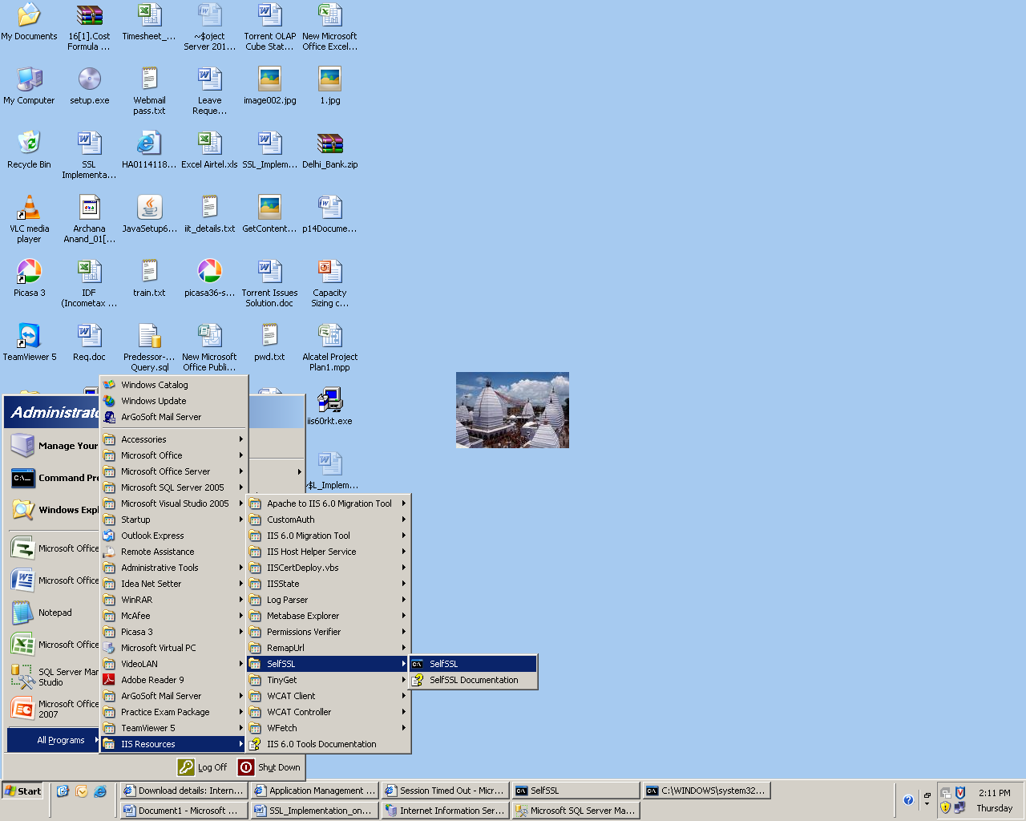
- Type the command
- Selfssl.exe /n:servername /k:1024 /v:7 /s:1 /p:443
(Note: 443 is the default port (port will help in bypass, else we can use other port also.)

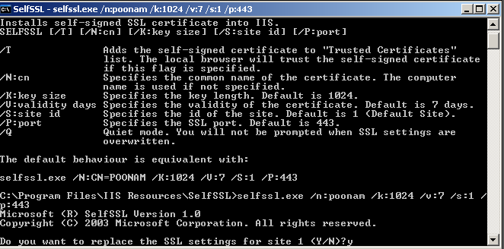

For OS: Window Server 2003
- Go to IIS
Run -> inetmgr -> right click the web site on which you want to implement SSL
And follow the below screen shot step by step
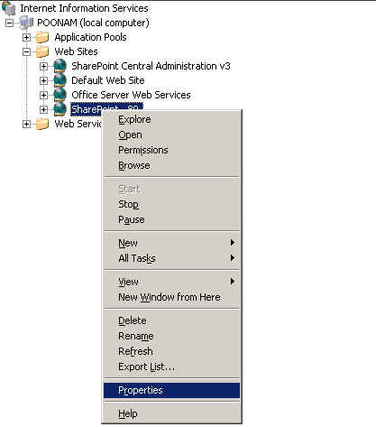

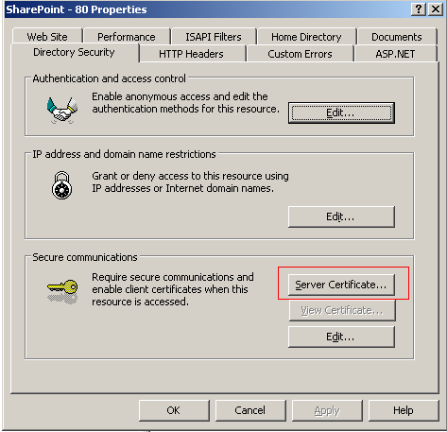

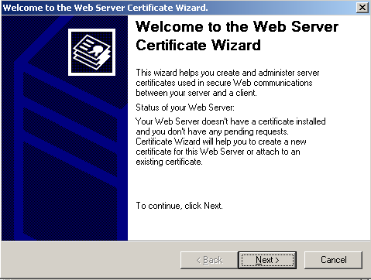
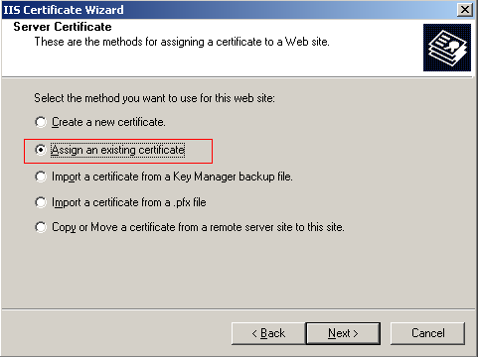

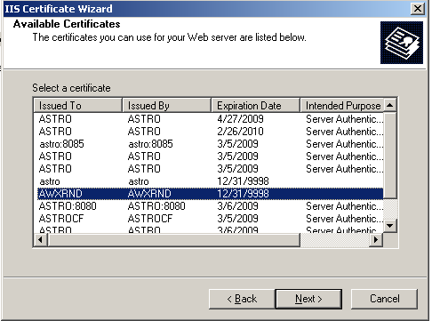

Assign the Port
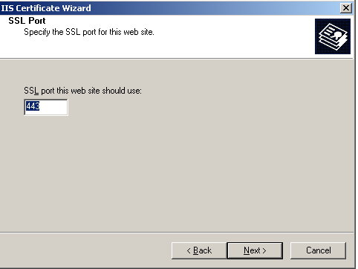

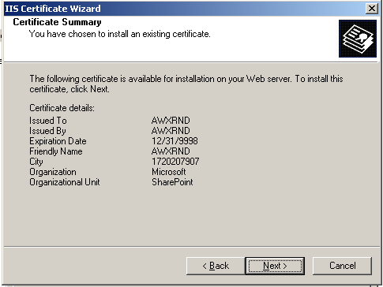
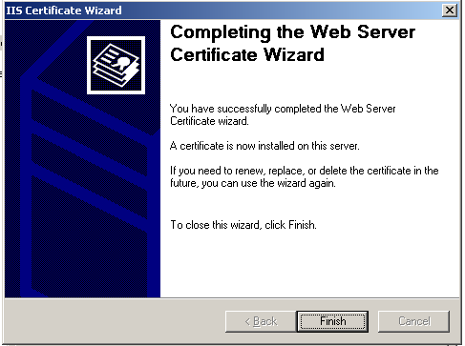

Click on the Certificate

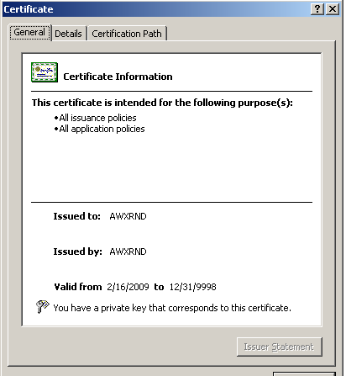

Note: There should not any red mark in certificate.

Click on edit.
Check both the checkbox
1. Require secure channel
2. Require 128-bit encryption

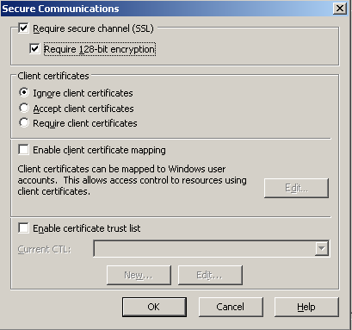
- Type run->inetmgr->web site->properties-directory security
- Click on edit enable anonymous access
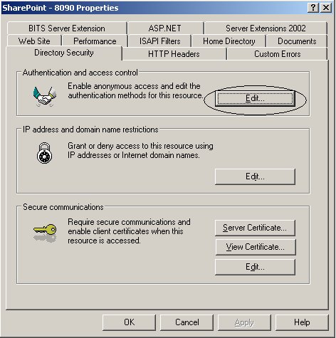

Checks the checkbox enable anonymous access
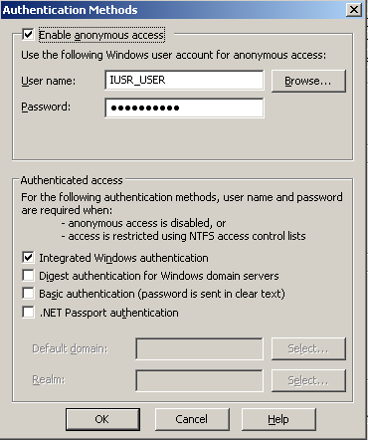
Click ok

Browse the site using https
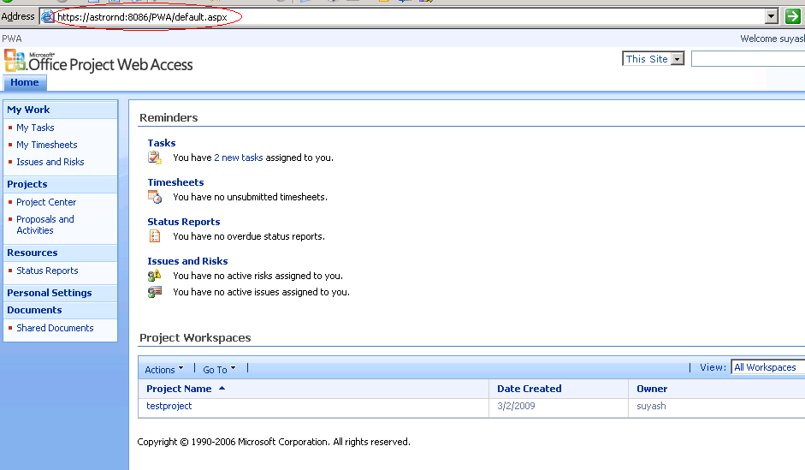

For OS 2008
Step 1 to 4 will be followed as it is.
5. Go to inetmgr
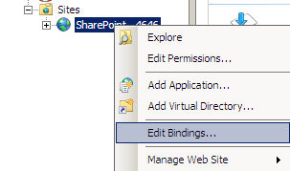

Click on server certificate

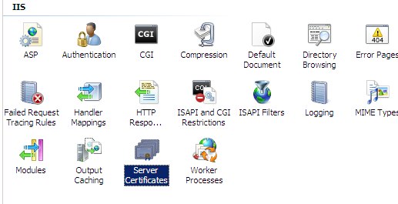

Follow the below screen shot
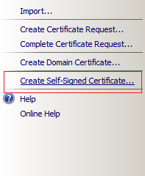
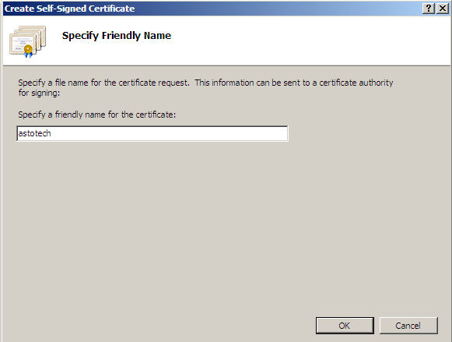

Right click the website -> edit site binding -> change to https
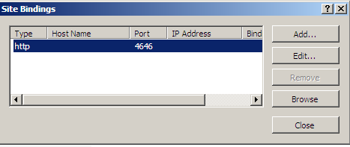

Assign the port and host name:
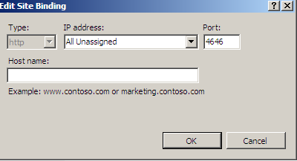

Enable SSl setting -> Apply

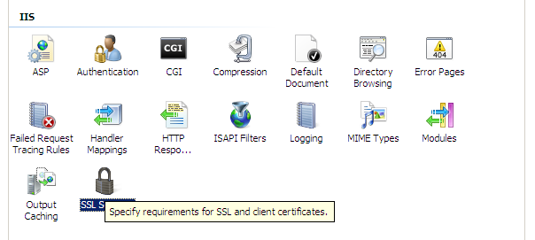

Enable Directory Browsing

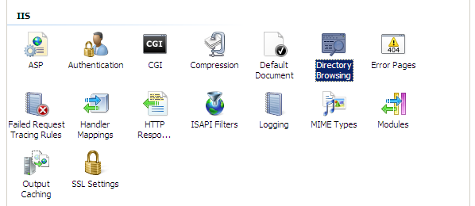

Go to Central administration -> Operation -> Alternate Access Mapping -> select the web site-> change to https-> Ok

Browse the site using https

